**Assembly Front Page**

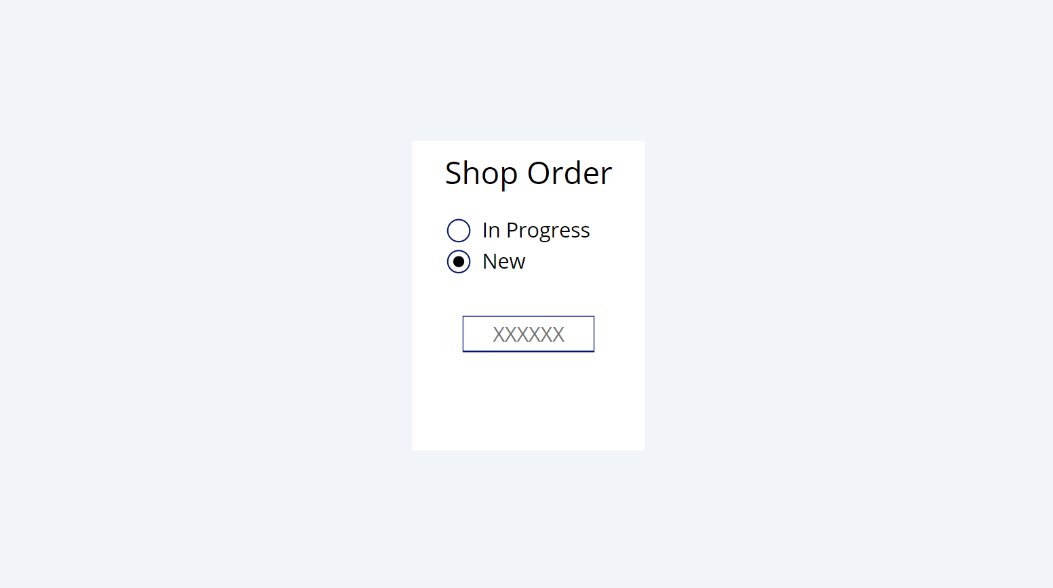

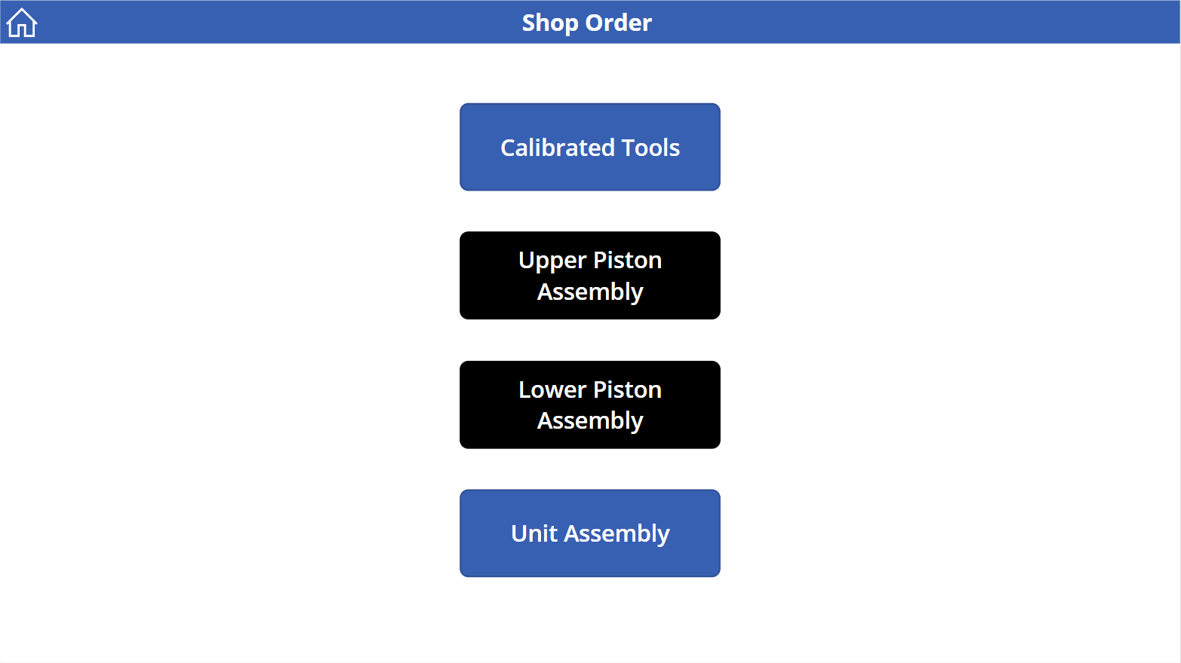**Assembly Selection**

**Data Capture**

**Written Procedure**

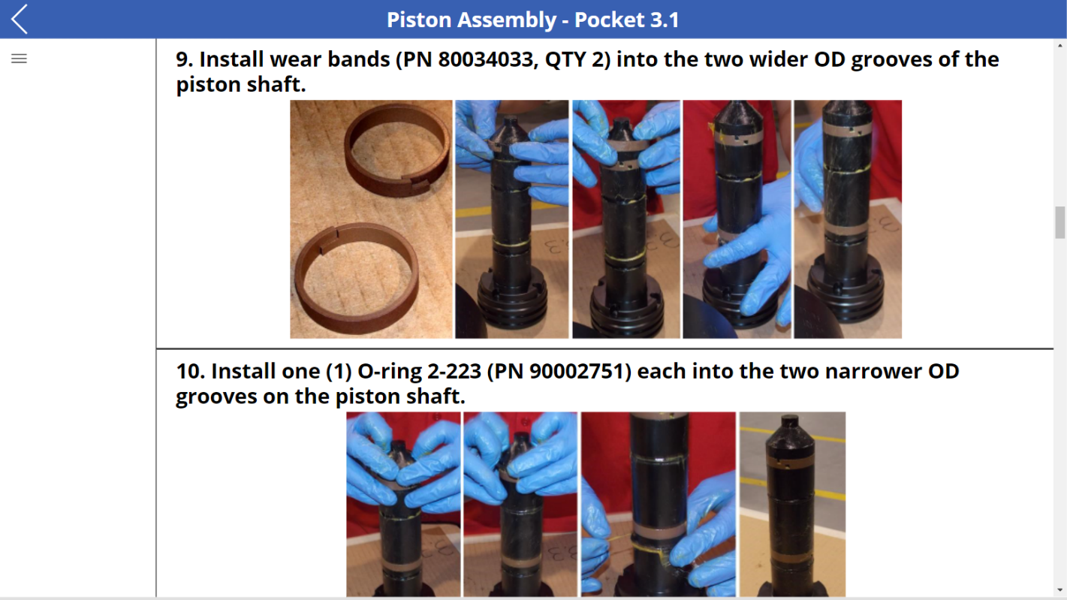

**Unit Assembly Dashboard**

